**I Want Eyes Like My Father’s Eyes Today**

[http://2.gravatar.com/avatar/e316002844f95d1c5ded19af6ec74a3f?s=140&d=mm&r=gJason Hardin](http://www.ingodsimage.com/author/admin/) April 27, 2016

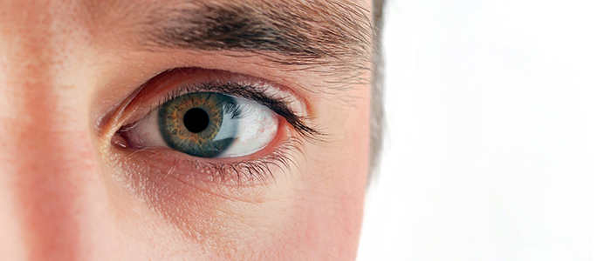When Habakkuk the prophet addressed the LORD, the Holy One, he described him in these terms:

“You who are of purer eyes than to see evil and cannot look at wrong…” (Hab 1:13)

I want eyes like my Father’s eyes today. How about you?

Granted, I can’t control everything that comes into my field of vision today. But I *can* control whether or not I will gaze. I have a choice between following or ignoring the clickbait. My eyes are the gates of my mind. When I willfully open those gates and yield access, access is granted because I *chose* to grant it.

My Creator is of purer eyes than to see evil and cannot look at wrong. He is the Holy One. He calls *me* to be holy in all my conduct (1 Pet 1:15-16). In order to answer that call, I must “prepare” my mind “for action,” determining to be “sober-minded” and “setting” my hope “fully on the grace” that will be brought to me “at the revelation of Jesus Christ” (1 Pet 1:13).

All of which means: if I want eyes like my Father’s eyes today, the time to prepare is **now**. The decision to be sober-minded is new every morning. The gates of my mind must be secured–“I have made a covenant with my eyes” (Job 31:1)–and the rightful King must be “set” on the throne of my heart. “My hope is built on nothing less than Jesus’ blood and righteousness.”

I want eyes like my Father’s eyes today. How about you?